### Promote More Creative,



**Connected, and Collaborative Teams**

INCLUDE is a research-based solution to dramatically improve inclusion, collaboration, and team interactions throughout your organisation. This program provides a three-part strategy to support diversity and drive inclusion at scale:

FIND **COMMON GROUND**™

Help People Feel That They Belong

**LIFT**

**PEOPLE**

UP™

Make People Feel Valued and Respected

HELP **CREATE CLARITY**™

Share Information and Help People Choose

###### What is Diversity Without Inclusion?

Diverse organisations tend to have stronger bottom lines, but only when all employees feel respected and valued. That’s where inclusion comes in.

Organisations that promote inclusiveness unlock collective intelligence to become more creative and collaborative.

###### Send the Right Social Signals

The subtle signals we send others every day generate feelings of either inclusion or exclusion. Even a

subtle comment or action can unintentionally trigger a social threat, causing a team member to feel excluded or to completely disengage. Our research shows that if you aren’t actively including, you are accidentally excluding.

**INCLUDE** gives employees and managers an easy to recall inclusion framework, based on the ground- breaking SCARF® Model, equipping them to dramatically improve their interactions and foster stronger working relationships in real-time.



neuroleadership.com



**AWAY** THREAT

Exclusion

**TOWARD** REWARD

Inclusion

**STATUS CERTAINTY AUTONOMY RELATEDNESS FAIRNESS**

The SCARF® Model



###### Solution Overview



**Research Summaries** for a deeper dive into the brain science

Practice Tools

to support habit formation through practice

**Meeting Guides** for guided application to real workplace scenarios

Activities

for long-term sustainment and learning

**Digital Learning Solution (DLS):**

Bite-sized audio and video content delivered across four weeks to thousands of managers at a time

**Integrated Learning Solution (ILS):**

Three 90-minute sessions using NLI’s HIVE (High Impact Virtual Experience) methodology, impacting hundreds to thousands of participants

**In-Person: Workshop**

Expert-led, generative learning experiences, offered as a half day session with tailoring options to fit your organisation’s needs

###### Days to Integrate

**30**

The INCLUDE Digital Learning Solution seamlessly integrates into your organisation and guides every employee to build inclusive habits and drive stronger social interactions and collaborations.

Get **5-Minute Research Videos** for an overview of the core content and a Live Webinar or a **Discussion Toolkit** for a holistic, interactive debrief.



**Scale** Roll out to 100s or 1000s of people at once **Speed** Small bites of digital info via a 30-day campaign **Impact** Brain-based learning that “sticks”

FOLLOW-UP

Sustainment

LAUNCH

FIND COMMON GROUND

Help People Feel That They Belong

LIFT PEOPLE UP

Make People Feel Valued and Respected

HELP CREATE CLARITY

Share Information and Help People Choose

INTERACTIVE WEBINAR OR DISCUSSION TOOLKIT

DIRECT REPORT ENGAGEMENT



#### For more information

North America



e: [northamerica@neuroleadership.com](mailto:northamerica@neuroleadership.com) | p: +01 (212) 260 2505

Europe, Middle East, and Africa



e: [emea@neuroleadership.com](mailto:emea@neuroleadership.com) | p: +44 (0) 845 456 3493

Asia Pacific



e: [apac@neuroleadership.com](mailto:apac@neuroleadership.com) | p: +61 2 9300 9878

### Make More Inclusive,



**Informed, and Successful Hiring Decisions**

**SELECT** is a research-based solution designed to mitigate the specific biases that undermine hiring decisions. This program uses brain-friendly techniques to teach hiring managers how to remove bias during each of the three key phases of the hiring process:

RESUME

**REVIEW**

Embrace the Evidence

**INTERVIEW**

Follow a Process

**CHOOSE**

A CANDIDATE

Challenge Your Thinking

###### Unconscious Bias

Bias happens when the brain uses shortcuts or rules of thumb to make decisions quickly. Unfortunately, this can lead to ineffective evaluation of information and, ultimately,

a poor decision. This is especially detrimental in the context of hiring decisions.

Simply raising awareness about bias is not enough to move the needle because people aren’t capable of “catching” themselves being biased. The only way to get rid of unconscious bias in hiring is to proactively implement research-based mitigation strategies.

###### How SELECT Promotes Successful Hiring Decisions

**SELECT** applies a framework known as the SEEDS Model® by identifying how different biases, such as the similarity bias or experience bias, impact the hiring process.

Then, **SELECT** provides managers with three easily applicable habits that mitigate these biases when reviewing resumes, interviewing, and choosing a candidate.

###### SELECT for Recruiters



**SELECT** is also available for recruiters, and includes a focus on mitigating bias in intake conversations with hiring managers.

**Biases That Impact the Hiring Process: The SEEDS Model®**



**S**imilarity Bias

**E**xpedience Bias

**E**xperience Bias

**D**istance Bias

**S**afety Bias



neuroleadership.com



© NeuroLeadership Institute

###### Solution Overview



**Research Summaries** for a deeper dive into the brain science

Practice Tools

to support habit formation through practice

Hiring Guides

for guided application to real workplace scenarios

Activities

for long-term sustainment and learning

**Distributed Learning Solution (DLS):**

Bite-sized video content delivered across four weeks to thousands of managers at a time

**High Impact Virtual Experience (HIVE):**

Three 90-minute sessions using NLI’s HIVE (High Impact Virtual Experience) methodology, impacting hundreds to thousands of participants

**In-Person Workshop:**

Expert-led, generative learning experiences, offered as a full-day session with tailoring options to fit your organization’s needs

###### Days to Integrate

**30**

The SELECT Distributed Learning Solution seamlessly integrates into your organization and supports managers to mitigate bias at every step of the hiring process.

Get **5-Minute Research Videos** for an overview of the core content and a Live Webinar or a **Discussion Toolkit** for a holistic, interactive debrief.



**Scale** Roll out to 100s or 1,000s of people at once **Speed** Small bites of digital info via a 30-day campaign **Impact** Brain-based learning that “sticks”

FOLLOW-UP

Sustainment

LAUNCH

EMBRACE THE EVIDENCE

Resume Review

FOLLOW A PROCESS

Remove the Biases Discussed Each Week

CHALLENGE YOUR THINKING

Choose a Candidate

INTERACTIVE WEBINAR OR DISCUSSION TOOLKIT

DIRECT REPORT ENGAGEMENT



#### For more information



**North America**



e: [northamerica@neuroleadership.com](mailto:northamerica@neuroleadership.com) | p: +01 (212) 260 2505

**Europe, Middle East, and Africa**



e: [emea@neuroleadership.com](mailto:emea@neuroleadership.com) | p: +44 (0) 845 456 3493

**Asia Pacific**



e: [apac@neuroleadership.com](mailto:apac@neuroleadership.com) | p: +61 2 9300 9878



|  |  |  |  |  |  |  |  |  |  |  |
| --- | --- | --- | --- | --- | --- | --- | --- | --- | --- | --- |
|  |  |  |  |  |  |  |  |  |  |  |



### There’s more energy than ever to increase diversity, equity, and inclusion



For organizations ready to harness that energy and help employees perform at their best, the NeuroLeadership Institute offers **ALLY**.

When people with influence speak up, others tend to listen and take action.

Based on our groundbreaking work with Microsoft and our seven years of success in consulting with organizations on diversity, equity, and inclusion, **ALLY** is a behavior-based, scalable approach to creating an equitable organization with three habits applicable worldwide. Allies use their advantaged positions to actively support colleagues in less advantaged positions. You can’t grow diverse talent without a sense of equity.





# Identify Inequity

Recognize the impact of injustice and unfairness.

# Increase Equity

Create more just and equitable outcomes.

# Drive Change

Collectively activate systemic change.

### Help create equity

Allies help create equity by supporting individuals and groups regardless of their own direct experience. Through our science-based approach, participants in **ALLY** will:

* Learn what allyship is and isn’t.
* Realize their power to create more equity.
* Learn how to create and sustain the right habits of allyship daily.

**To build equity in your organization, speak to your senior client advisor or email us at** [**northamerica@neuroleadership.com**](mailto:northamerica@neuroleadership.com)

neuroleadership.com



© NeuroLeadership Institute



|  |  |  |  |  |  |  |  |  |  |  |
| --- | --- | --- | --- | --- | --- | --- | --- | --- | --- | --- |
|  |  |  |  |  |  |  |  |  |  |  |

The Neuroscience of Leading with Empathy



**Our research-based approach to creating an affiliative, supportive workplace culture.**

**CARE** features a suite of brain-based tools to help leaders, managers, and employees connect with others — when it matters most — by increasing their understanding of empathy. The three-step program will help participants develop skills to connect in high-quality ways:

**NOTICE**

Cut the noise, and find signals of underlying emotion.

**UNDERSTAND**

Ask questions with intent, and listen to clarify.

**ACT**

Check your intent, and make support easy to accept.

**Connection begins when we stop making assumptions**

### Conventional wisdom says

empathy is one trait that you either have or you don’t.



**But research shows** it’s actually three separate components: emotional, cognitive, and behavioral, each with their own challenges and traps. And with a growth mindset and

behaviors that lead to habits, each can be developed.

Poor connections that fail to incorporate empathy contribute to lower performance, productivity, satisfaction, and retention. But when you lean into the power of quality connections, the impact reaches far beyond those measures. Positive emotions get amplified, biases are mitigated, and breakthroughs happen.

**CARE** is an effective solution for creating quality connections at scale because it’s designed to reward both sides of the connection, which drives a continuously regenerative effect.

###### The Quality Connection Continuum™



**Empathy**

**Emotional**

**Cognitive**

**Behavioral**

**Notice**

**Understand**

**Act**

**CARE** teaches the common challenges in each area and the daily behaviors employees need to be more empathetic,

increasing engagement, sense of belonging, and productivity.

**Emotional empathy:** Notice the experience of another

through proactive interpersonal **contact**

**Cognitive empathy:** Understand the person’s experience

through **curiosity** to listen and learn

**Behavioral empathy:** Act by offering meaningful, easy-to-

accept support through **intent**

neuroleadership.com



© NeuroLeadership Institute



|  |  |  |  |  |  |  |  |  |  |  |
| --- | --- | --- | --- | --- | --- | --- | --- | --- | --- | --- |
|  |  |  |  |  |  |  |  |  |  |  |

###### A Brain-Based Approach to Behavior Change

**CARE** makes it easy for leaders and employees to learn and apply the habits of empathy in interpersonal situations immediately.

**CARE** employs three evidence-based strategies to ensure success:

**If-Then Plans**



Conscious shifts that bring empathy into everyday decisions and interactions

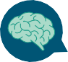

**Distributed Learning Solution (DLS):**

Bite-sized video content

delivered across four weeks to thousands of managers at a time

**Decision Guides**

Three-step protocols for key people and business decisions

**Preventive Measures**



Removing barriers that create disconnects

**High Impact Virtual Experience (HIVE):**

Three 60-minute sessions

using NLI’s HIVE methodology, impacting hundreds to thousands of participants

**Half-Day Workshop:**

Expert-led, generative learning

experiences, offered as a half-day session with tailoring options to fit your organization’s needs





**30**

**Days to Integrate**

The **CARE** Distributed Learning Solution seamlessly integrates into your organization and turns these

essential skills into sustainable habits. Get **5-Minute Research Videos** for an overview of the core content and a **Live Webinar** or a **Discussion Toolkit** for a holistic, interactive debrief.

**Scale** Roll out to 100s or 1,000s of people at once

**Speed** Small bites of digital info via a 30-day campaign

**Impact** Brain-based learning that “sticks”

**Launch**

**Notice**

**Understand**

**Act**

**Webinar or Toolkit**

**Sustainment**

Week 1

Week 2

Week 3

Week 4

30 days

#### For more information

**North America**



e: [northamerica@neuroleadership.com](mailto:northamerica@neuroleadership.com) | p: +01 (212) 260 2505

**Europe, Middle East, and Africa**



e: [emea@neuroleadership.com](mailto:emea@neuroleadership.com) | p: +44 (0) 845 456 3493

**Asia Pacific**



e: [apac@neuroleadership.com](mailto:apac@neuroleadership.com) | p: +61 2 9300 9878

The Neuroscience of Leading with Empathy



|  |  |  |  |  |  |  |  |  |  |  |
| --- | --- | --- | --- | --- | --- | --- | --- | --- | --- | --- |
|  |  |  |  |  |  |  |  |  |  |  |



®

### Increasing the Quality of Performance Conversations So Everyone Can Learn, Grow, and Achieve

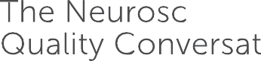

**CONNECT** features a suite of brain-based tools built upon 20 years of research

in human performance and workplace interaction. This scalable solution enables managers to increase the effectiveness of their performance conversations by developing their skills:

**BUILD**

PARTNERSHIP

with the SCARF® Model

**ACTIVATE**

INSIGHT

with the TAPS Model®

**FOCUS ON**

LEARNING

by priming for growth mindset

###### Our Intent Rarely Matches Our Impact

Less than 1% of managers possess both goal- focused and people-focused skills.* This is partly because most workplace training focuses on technical development over “softer” communication skills. But it’s also due to competing networks in the brain fighting to set goals and maintain social skills. The result of this dilemma is that few workplace conversations turn out as intended.

###### The Benefits of a Quality Conversation

Having better quality conversations has a significant impact on an organisation.

Employees:



* Solve problems faster
* Are more engaged
* Perform better
* Grow faster

###### A Brain-Based Approach

The brain-based strategies used to hold quality conversations involve tuning into the social drivers of human behaviour, evoking a mindset of growth, and promoting solution seeking through insight. The types of conversation we employ these strategies in include:



**Everyday Performance Conversations**

**Project-based Performance Conversations**

**Annual Performance Conversations**

**Longer-term Career Conversations**

*Management Research Group, January 2012

neuroleadership.com





|  |  |  |  |  |  |  |  |  |  |  |
| --- | --- | --- | --- | --- | --- | --- | --- | --- | --- | --- |
|  |  |  |  |  |  |  |  |  |  |  |

###### Solution Overview



**Research Summaries** for a deeper dive into the brain science

Practice Tools

to support habit formation through practice

**Conversation Guides** for guided application to real workplace scenarios

Activities

for long-term sustainment and learning

**Distributed Learning Solution (DLS):**

Bite-sized video content delivered across four weeks to thousands of managers at a time

**High Impact Virtual Experience (HIVE):**

Three 90-minute sessions using NLI’s HIVE (High Impact Virtual Experience) methodology, impacting hundreds to thousands of participants

**In-Person Workshop:**

Expert-led, generative learning experiences, offered as a full-day session with tailoring options to fit your organisation’s needs

###### Days to Integrate

**30**

The **CONNECT** Distributed Learning Solution seamlessly integrates into your organisation and turns these essential skills into sustainable habits.

Get **5-Minute Research Videos** for an overview of the core content

and a Live Webinar or a **Discussion Toolkit** for a holistic, interactive debrief.



**Scale** Roll out to 100s or 1,000s of people at once **Speed** Small bites of digital info via a 30-day campaign **Impact** Brain-based learning that “sticks”

FOLLOW-UP

Sustainment

FOCUS ON LEARNING

INTERACTIVE WEBINAR OR DISCUSSION TOOLKIT

LAUNCH

BUILD PARTNERSHIP

Understand Social Threat and Reward

ACTIVATE INSIGHT

Focus on Positive Solutions

Embody and Promote a Growth Mindset

DIRECT REPORT ENGAGEMENT



#### For more information

North America



e: [northamerica@neuroleadership.com](mailto:northamerica@neuroleadership.com) | p: +01 (212) 260 2505



Europe, Middle East, and Africa



e: [emea@neuroleadership.com](mailto:emea@neuroleadership.com) | p: +44 (0) 845 456 3493

Asia Pacific



e: [apac@neuroleadership.com](mailto:apac@neuroleadership.com) | p: +61 2 9300 9878



|  |  |  |  |  |  |  |  |  |  |  |
| --- | --- | --- | --- | --- | --- | --- | --- | --- | --- | --- |
|  |  |  |  |  |  |  |  |  |  |  |

### Break Unconscious Bias in Your Organisation

**DECIDE** is a research-based solution that features easy-to-digest

tools to help managers and employees immediately make more informed, effective, and confident decisions when it matters most. This program consists

of a three-step process for mitigating bias in a way that has never been seen before:

**LABEL**

Identify what type of unconscious bias you may be experiencing

**MITIGATE**

Implement strategies to mitigate the impact of bias

**ENGAGE**

Implement strategies to engage your team

###### If You Have a Brain, You Have Bias

Biases are deeply ingrained, nonconscious drivers that heavily influence every decision or judgment we make. While they enable us to make decisions

efficiently, they blind us to new information and inhibit us from considering valuable options when making important decisions.

**DECIDE** is an effective solution for breaking bias at scale because it’s designed to remove bias from the process, not the person.

###### Knowing About Bias Isn’t Enough

Conventional wisdom says that teaching people about bias will help them stop being biased, but research in cognitive neuroscience has shown that knowing about bias isn’t enough.

###### The SEEDS Model®

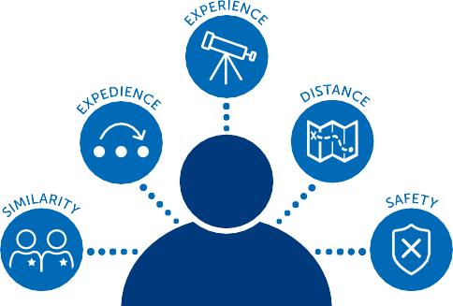Working with a team of neuroscientists, we identified common processes that drive 100+ biases in the brain, ultimately organising them into five categories. We then created mitigation strategies to serve each category.

###### Brain-Based Bias Mitigation Strategies

**DECIDE** employs two evidence-based strategies to ensure success:

DECISION GUIDES

**If-Then Plans** Breaking bias in everyday decisions and interactions

**Decision Guides** Three-step protocols for key people and business decisions

neuroleadership.com





|  |  |  |  |  |  |  |  |  |  |  |
| --- | --- | --- | --- | --- | --- | --- | --- | --- | --- | --- |
|  |  |  |  |  |  |  |  |  |  |  |

###### Solution Overview



**Research Summaries** for a deeper dive into the brain science

Practice Tools

to support habit formation through practice

**Decision Guides** for guided application to real workplace decisions

Activities

for long-term sustainment and learning

**Digital Learning Solution (DLS):**

Bite-sized audio and video content delivered across four weeks to thousands of managers at a time

**High Impact Virtual Experience (HIVE):**

Three 90-minute sessions using NLI’s HIVE (High Impact Virtual Experience) methodology, impacting hundreds to thousands of participants

**In-Person Workshop:**

Expert-led, generative learning experiences, offered as a half- day session with tailoring options to fit your organisation’s needs

###### Days to Integrate

**30**

The **DECIDE** Digital Learning Solution seamlessly integrates

into your organisation and turns these essential skills into sustainable habits.





Get **5-Minute Research Videos** for an overview of the core content and a Live Webinar or a **Discussion Toolkit** for a holistic, interactive debrief.

**Scale Speed**

**Impact**

Roll out to 100s or 1,000s of people at once Small bites of digital info via a 30-day campaign

Brain-based learning that “sticks”

FOLLOW-UP

Sustainment

ENGAGE

INTERACTIVE DISCUSSION

MITIGATE

5-minute video Research Summary

Practice Tool

5-minute video Research Summary

Practice Tool

LAUNCH

LABEL

5-minute video Research Summary Practice Tool



#### For more information

North America



e: [northamerica@neuroleadership.com](mailto:northamerica@neuroleadership.com) | p: +01 (212) 260 2505

Europe, Middle East, and Africa



e: [emea@neuroleadership.com](mailto:emea@neuroleadership.com) | p: +44 (0) 845 456 3493

Asia Pacific



e: [apac@neuroleadership.com](mailto:apac@neuroleadership.com) | p: +61 2 9300 9878



|  |  |  |  |  |  |  |  |  |  |  |
| --- | --- | --- | --- | --- | --- | --- | --- | --- | --- | --- |
|  |  |  |  |  |  |  |  |  |  |  |

DEVELOP



The Neuroscience of Career Conversations™

### Build a Culture of Feedback

**DEVELOP** improves long-term growth conversations by helping managers understand their people, inspire growth, and partner with employees

to be their best. Through a suite of brain-based tools, this program will

teach managers three simple habits to apply at the beginning, middle, and end of long-term growth conversations:

**REFLECT** TO

UNDERSTAND

Promote self-awareness and openness

**EXPAND** THE

CONVERSATION

Bring focus to a higher level

**PARTNER**

PROACTIVELY

Identify next steps and continue to support

 

###### Impact of Career Conversations

While 89% of employees say that regular career conversations would motivate them to seek internal roles within an organisation, only 16% say they have these types of conversations with their managers. Furthermore, only 30%

of managers feel confident having growth conversations with their people.*

Research suggests that this is because career conversations are one of



**89%**

**30%**

**16%**

the most challenging types of conversations to have at work. However, research also shows that when employees have someone at work who is encouraging their development and growth, profitability and employee retention increase.**

###### Ask the Right Questions

Growth conversations can feel hard not just because a manager can’t always promote people but also because they are personal, abstract and future-focused, all of which can feel uncomfortable. Instead of expecting to have all the answers, managers can shift to partnering with their team member to find the answers.

It turns out it’s all about asking the right questions in career conversations. By changing the focus to asking questions:

* The conversation becomes more comfortable for the manager and the employee.
* Strengths and motivations are uncovered, leading to a better employee-role fit.
* Thinking is lifted and focus is directed on the future and broader options.
* Long-term growth is supported when the manager and employee partner with each other.

* Right Management, 2016

** Gallup Inc., 2017

neuroleadership.com





|  |  |  |  |  |  |  |  |  |  |  |
| --- | --- | --- | --- | --- | --- | --- | --- | --- | --- | --- |
|  |  |  |  |  |  |  |  |  |  |  |

###### Solution Overview



**Research Summaries** for a deeper dive into the brain science

Practice Tools

to support habit formation through practice

Guides

for guided application to real workplace scenarios

Activities

for long-term sustainment and learning

**Distributed Learning Solution (DLS):**

Bite-sized video content delivered across four weeks to thousands of managers at a time

**High Impact Virtual Experience (HIVE):**

Three 90-minute sessions using NLI’s HIVE (High Impact Virtual Experience) methodology, impacting hundreds to thousands of participants

**In-Person Workshop:**

Expert-led, generative learning experiences, offered as a full-day session with tailoring options to fit your organisation’s needs

###### Days to Integrate

**30**

The **DEVELOP** Distributed Learning Solution seamlessly integrates into your organisation and turns these essential skills into sustainable habits.

Get **5-Minute Research Videos** for an overview of the core content and a Live Webinar or a **Discussion Toolkit** for a holistic, interactive debrief.



**Scale** Roll out to 100s or 1,000s of people at once **Speed** Small bites of digital info via a 30-day campaign **Impact** Brain-based learning that “sticks”

FOLLOW-UP

Sustainment

LAUNCH

REFLECT TO UNDERSTAND

Promote Self-Awareness and Openness

EXPAND THE CONVERSATIONS

Bring Focus to a Higher Level

PARTNER PROACTIVELY

Identify Next Steps and Continue

to Supports

INTERACTIVE WEBINAR OR DISCUSSION TOOLKIT

DIRECT REPORT ENGAGEMENT



#### For more information



North America



e: [northamerica@neuroleadership.com](mailto:northamerica@neuroleadership.com) | p: +01 (212) 260 2505

Europe, Middle East, and Africa



e: [emea@neuroleadership.com](mailto:emea@neuroleadership.com) | p: +44 (0) 845 456 3493

Asia Pacific



e: [apac@neuroleadership.com](mailto:apac@neuroleadership.com) | p: +61 2 9300 9878



|  |  |  |  |  |  |  |  |  |  |  |
| --- | --- | --- | --- | --- | --- | --- | --- | --- | --- | --- |
|  |  |  |  |  |  |  |  |  |  |  |

### Assess Performance Accurately



DIFFERENTIATE helps managers in your organisation to make informed, accurate, and fair evaluations of employee contributions.

This program provides a three-part strategy to mitigate unconscious

bias in assessment, and communicate those decisions effectively, at scale:

GATHER **THE RIGHT DATA**

Start with

the Right Information

MAKE AN

**INFORMED**

**RECOMMENDATION**

Accurately Evaluate Information You Have Gathered

COMMUNICATE **FOR POSITIVE IMPACT**

Minimise Threat to Focus on Development

###### Assessment is Challenging

Research shows that two-thirds of employees receiving the highest performance scores are not actually the highest performers. Because of this disconnect, nearly 90% companies want to improve their approach to evaluation.*

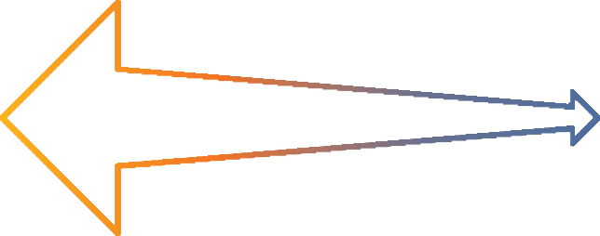

To do so, managers will need to learn how to keep unconscious bias from undermining

###### Mitigate Bias in Evaluation

The NeuroLeadership Institute developed The SEEDS Model® to help managers label and mitigate bias.

**DIFFERENTIATE** leverages The SEEDS Model® to support managers to both gather the right information and weigh that information accurately, allowing them to get a complete picture of performance



their judgement.

90%

of companies

want to **improve**

**S**imilarity Bias

**E**xpedience Bias

**E**xperience Bias

**D**istance Bias

**S**afety Bias

evaluations*

###### Communicate Decisions

Performance evaluations are often highly threatening and it’s important for managers to keep employees in the right mental state. The SCARF Model® outlines the five domains of social threat and reward: Status, Certainty, Autonomy, Relatedness, and Fairness. **DIFFERENTIATE** teaches managers how to mitigate threat and create reward in each of these domains, priming employees’ brains to effectively process information and support future growth.

*CEB Corporate Leadership Council, 2012

neuroleadership.com





|  |  |  |  |  |  |  |  |  |  |  |
| --- | --- | --- | --- | --- | --- | --- | --- | --- | --- | --- |
|  |  |  |  |  |  |  |  |  |  |  |

###### Solution Overview



**Research Summaries** for a deeper dive into the brain science

Practice Tools

to support habit formation through practice

Guides

for guided application to real workplace scenarios

Activities

for long-term sustainment and learning

**Distributed Learning Solution (DLS):**

Bite-sized video content delivered across four weeks to thousands of managers at a time

**High Impact Virtual Experience (HIVE):**

Three 90-minute sessions using NLI’s HIVE (High Impact Virtual Experience) methodology, impacting hundreds to thousands of participants

**In-Person Workshop:**

Expert-led, generative learning experiences, offered as a full-day session with tailoring options to fit your organisation’s needs

###### Days to Integrate

**30**

The **DIFFERENTIATE** Distributed Learning Solution seamlessly integrates into your organisation and turns these essential skills into sustainable habits.

Get **5-Minute Research Videos** for an overview of the core content and a Live Webinar or a **Discussion Toolkit** for a holistic, interactive debrief.



**Scale** Roll out to 100s or 1000s of people at once **Speed** Small bites of digital info via a 30-day campaign **Impact** Brain-based learning that “sticks”

FOLLOW-UP

Sustainment

LAUNCH

GATHER THE MOST IMPORTANT DATA

CHECK YOUR THINKING

COMMUNICATE TO MOTIVATE

INTERACTIVE WEBINAR OR DISCUSSION TOOLKIT

DIRECT REPORT ENGAGEMENT



#### For more information

North America



e: [northamerica@neuroleadership.com](mailto:northamerica@neuroleadership.com) | p: +01 (212) 260 2505

Europe, Middle East, and Africa



e: [emea@neuroleadership.com](mailto:emea@neuroleadership.com) | p: +44 (0) 845 456 3493

Asia Pacific



e: [apac@neuroleadership.com](mailto:apac@neuroleadership.com) | p: +61 2 9300 9878



|  |  |  |  |  |  |  |  |  |  |  |
| --- | --- | --- | --- | --- | --- | --- | --- | --- | --- | --- |
|  |  |  |  |  |  |  |  |  |  |  |

##### The Neuroscience of Hybrid Leadership

When it comes to returning to the office, employees are split three ways on how they would like to work going forward:



One third say they’d like

**Hybrid**

**33.3%**

**In-Office**

**33.3%**

**Remote**

**33.3%**

## to go back to the office

One third say they’d like

## to remain completely remote

One third say they’d like

## a mix of the two (hybrid)

Research shows that a hybrid structure can work, and work well… but only if managers have the skills necessary to lead hybrid teams.

Given this new reality, the NeuroLeadership Institute has designed a new program to equip leaders with the skills they need to thrive in the new hybrid work environment: **FLEX™—The Neuroscience of Hybrid Leadership**.

#### How it works

**76%**

Despite the uncertainty of returning to the office and a drastic shift in the way we work, studies show that the majority of both employers and employees reported positive effects from a year of remote work, with our own research showing that **76%** of employees have been just as productive or more since the pandemic.

Finding a balance between having your employees work remotely,

at the office, or come in the office some days and stay home other days

sounds complicated. However, after consulting with various industry leaders and organizations, we’ve developed a program that applies neuroscience research where it matters most—to develop the specific mindset, processes, and skills needed to be highly effective in a hybrid world.

neuroleadership.com

© NeuroLeadership Institute

|  |  |  |  |  |  |  |  |  |  |  |
| --- | --- | --- | --- | --- | --- | --- | --- | --- | --- | --- |
|  |  |  |  |  |  |  |  |  |  |  |

**This learning solution includes:**



**FLEX™–The Neuroscience of Hybrid Leadership**



# Flex Your Mindset

Activate a growth mindset

Solve for autonomy, manage for fairness

# Tap Potential

Goal setting, check-ins, and feedback

Mitigate biases in people processes

# Maximize Time

Conduct fewer, shorter, better meetings

Optimally include

This framework will equip your organization at every level with the right behaviors, habits, and tactical skills to thrive in a hybrid workplace.

The **FLEX** program will help leaders throughout the organization provide autonomy and fairness for employees, address cognitive challenges, and build on the upsides of a hybrid work environment.

#### You’ll find that...

**Your employees will be less stressed and be more productive.**

**Your organization will have a competitive advantage to attract and**

**retain talent in a tight marketplace.**

**Your innovation and culture will thrive.**

**For more information**



|  |  |
| --- | --- |
|  |  |
|  |  |
|  |  |
|  |  |
|  |  |

**North America**



e: [northamerica@neuroleadership.com](mailto:northamerica@neuroleadership.com) | p: +01 (212) 260 2505

**Europe, Middle East, and Africa**



e: [emea@neuroleadership.com](mailto:emea@neuroleadership.com) | p: +44 (0) 845 456 3493

**Asia Pacific**



e: [apac@neuroleadership.com](mailto:apac@neuroleadership.com) | p: +61 2 9300 9878

neuroleadership.com

© NeuroLeadership Institute



|  |  |  |  |  |  |  |  |  |  |  |
| --- | --- | --- | --- | --- | --- | --- | --- | --- | --- | --- |
|  |  |  |  |  |  |  |  |  |  |  |

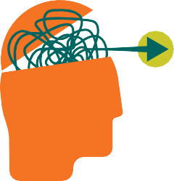FOCUS



The Neuroscience of Thriving Through Crisis

### Stay focused and productive through crisis

**FOCUS** resources are science-based, insight-rich, and action-focused. They help people at any level in your organization and are applicable across industries

and geographies. **FOCUS** covers the essential habits to practice in three critical areas:



# Take Care of Yourself

Keep your brain in the best possible

shape every day

# Look After Each Other

Help others stay productive with the right practices

# Deliver What Matters

Learn to prioritize better and move faster as a team

During difficult times, the human brain goes on a kind of scavenger hunt for **certainty**, **autonomy**, and **relatedness** — to better understand our environment, gain control of the situation, and feel connected to others. Unfortunately, crisis can leave all three in short supply. As a result, we may feel threatened: Our prefrontal cortex shuts down, we lose our ability to think rationally, and we struggle to think clearly.

**FOCUS** is an effective solution for addressing these threats, to help people reengage with their work and concentrate on what matters most. The science of social threat and reward, expressed in the SCARF® Model, can help teams achieve these outcomes.



**AWAY** THREAT

Threat Is Stronger

**STATUS CERTAINTY AUTONOMY RELATEDNESS FAIRNESS**

**TOWARD** REWARD

Reward Is Better

**For more information, email us at** [**northamerica@neuroleadership.com**](mailto:northamerica@neuroleadership.com)

neuroleadership.com



© NeuroLeadership Institute





|  |  |  |  |  |  |  |  |  |  |  |
| --- | --- | --- | --- | --- | --- | --- | --- | --- | --- | --- |
|  |  |  |  |  |  |  |  |  |  |  |



™

### Thrive Through Big and Small Changes



The goal of **GROW: The Neuroscience of Growth Mindset™**, is to help individuals be more agile and flexible in their everyday activities while setting

up opportunities for innovation and learning. **GROW** flips old paradigms about mindsets and presents a new, innovative approach to remain flexible, positive, and engaged while identifying ways to embrace a growth mindset. The content is informed by cutting-edge research in the field of neuroscience and provides critical insight into how to notice when you are experiencing a fixed mindset and identify ways to shift to a growth mindset by following three key habits:



**VALUE PROGRESS**

**EXPERIMENT**

**LEARN FROM OTHERS**

###### Outlook Can Influence Success

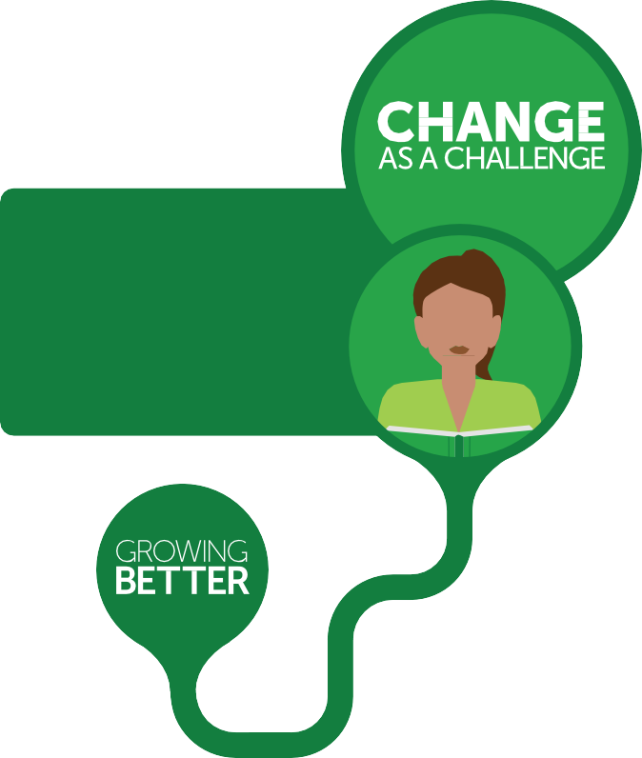Mindsets determine whether we experience change as a threat or a challenge. **Threat** creates negative stress that undermines productivity, along with mental and physical well-being. **Challenge** energises and helps your brain function at its best.

**Growth mindset thinking** helps us see mistakes as valuable opportunities to learn and makes us eager to innovate and welcome the **challenge** of change.



**Fixed mindset thinking,** the most common mindset among today’s employees, leads us to avoid mistakes at all costs,

remain stuck in old ways of doing things, and see change as a major **threat**.

Our interactions with peers, the way we deliver feedback, and even how we ask questions can subconsciously nudge a person toward one mindset or the other. This has a fundamental influence on employee engagement and professional performance, and can ultimately make or break an organisation’s bottom line.

neuroleadership.com





|  |  |  |  |  |  |  |  |  |  |  |
| --- | --- | --- | --- | --- | --- | --- | --- | --- | --- | --- |
|  |  |  |  |  |  |  |  |  |  |  |

###### Solution Overview



**Research Summaries** for a deeper dive into the brain science

Practice Tools

to support habit formation through practice

**Growth Mindset Guides** for guided application to real workplace scenarios

Activities

for long-term sustainment and learning

**Distributed Learning Solution (DLS):**

Bite-sized audio and video content delivered across four weeks to thousands of managers at a time

**High Impact Virtual Experience (HIVE):**

Three 90-minute sessions using NLI’s HIVE (High Impact Virtual Experience) methodology, impacting hundreds to thousands of participants

**In-Person: Workshop:**

Expert-led, generative learning experiences, offered as a half-day session with tailoring options to fit your organisation’s needs

###### Days to Integrate

**30**

The **GROW** Distributed Learning Solution seamlessly integrates into your organisation and turns these essential skills into sustainable habits.

Get **5-Minute Research Videos** for an overview of the core content



and a Live Webinar or a **Discussion Toolkit** for a holistic, interactive debrief.

**Scale** Roll out to 100s or 1,000s of people at once **Speed** Small bites of digital info via a 30-day campaign **Impact** Brain-based learning that “sticks”

FOLLOW-UP

Sustainment



INTERACTIVE WEBINAR OR DISCUSSION TOOLKIT

LAUNCH

VALUE PROGRESS

EXPERIMENT

LEARN FROM OTHERS

DIRECT REPORT ENGAGEMENT



#### For more information



North America



e: [northamerica@neuroleadership.com](mailto:northamerica@neuroleadership.com) | p: +01 (212) 260 2505

Europe, Middle East, and Africa



e: [emea@neuroleadership.com](mailto:emea@neuroleadership.com) | p: +44 (0) 845 456 3493

Asia Pacific



e: [apac@neuroleadership.com](mailto:apac@neuroleadership.com) | p: +61 2 9300 9878



|  |  |  |  |  |  |  |  |  |  |  |
| --- | --- | --- | --- | --- | --- | --- | --- | --- | --- | --- |
|  |  |  |  |  |  |  |  |  |  |  |

### Build a Culture of Feedback



**IMPROVE** is a solution to help the people in your organisation share and receive feedback in a way that is less threatening and feels more “normal” and comfortable. This program provides a three-part strategy to support improvement and growth at scale:

ASK FOR

**FEEDBACK**

Explicitly, Broadly, and Often

WHAT TO

**BUILD ON**

Create a Toward State

WHERE TO

**REFOCUS**

Identify Specific Behaviors

and Strategies

###### People Need to Grow Faster Than Ever Before

*The most engaged employees receive feedback at least once per week.\**

Research suggests that frequent, targeted feedback is essential for top performance. The most engaged employees receive feedback at least once per week.* Only by seeing your work from another point of view, through feedback, can you begin to see the complete picture. Unfortunately, few people are getting the kind of feedback they need to grow.

###### Why Ask?

Asking for feedback helps regulate the brain’s threat response by increasing people’s sense of status and control. In addition, people can feel more comfortable sharing their viewpoint when it has been asked for and know it will be welcomed.

**IMPROVE** provides employees and managers with easy-to-recall habits to maximise

the effectiveness of asking for viewpoints. It also provides a simple framework for understanding what happens in the brain

when feedback works, and how we can share feedback for maximum impact.

**?**



*Can I please get some feedback?*

*Gallup Business Journal, June 2016

neuroleadership.com





|  |  |  |  |  |  |  |  |  |  |  |
| --- | --- | --- | --- | --- | --- | --- | --- | --- | --- | --- |
|  |  |  |  |  |  |  |  |  |  |  |

###### Solution Overview



**Research Summaries** for a deeper dive into the brain science

Practice Tools

to support habit formation through practice

Guides

for guided application to real workplace scenarios

Activities

for long-term sustainment and learning

**Distributed Learning Solution (DLS):**

Bite-sized video content delivered across four weeks to thousands of managers at a time

**High Impact Virtual Experience (HIVE):**

Three 90-minute sessions using NLI’s HIVE (High Impact Virtual Experience) methodology, impacting hundreds to thousands of participants

**In-Person Workshop:**

Expert-led, generative learning experiences, offered as a full-day session with tailoring options to fit your organisation’s needs

###### Days to Integrate

**30**

The **IMPROVE** Distributed Learning Solution seamlessly integrates into your organisation and turns these essential skills into sustainable habits.

Get **5-Minute Research Videos** for an overview of the core content and a Live Webinar or a **Discussion Toolkit** for a holistic, interactive debrief.



**Scale** Roll out to 100s or 1,000s of people at once **Speed** Small bites of digital info via a 30-day campaign **Impact** Brain-based learning that “sticks”

FOLLOW-UP

Sustainment

LAUNCH

ASK FOR FEEDBACK

WHAT TO BUILD ON

WHERE TO REFOCUS

INTERACTIVE WEBINAR OR DISCUSSION TOOLKIT

DIRECT REPORT ENGAGEMENT



#### For more information

North America



e: [northamerica@neuroleadership.com](mailto:northamerica@neuroleadership.com) | p: +01 (212) 260 2505

Europe, Middle East, and Africa



e: [emea@neuroleadership.com](mailto:emea@neuroleadership.com) | p: +44 (0) 845 456 3493

Asia Pacific



e: [apac@neuroleadership.com](mailto:apac@neuroleadership.com) | p: +61 2 9300 9878



|  |  |  |  |  |  |  |  |  |  |  |
| --- | --- | --- | --- | --- | --- | --- | --- | --- | --- | --- |
|  |  |  |  |  |  |  |  |  |  |  |



### Collaborate with confidence

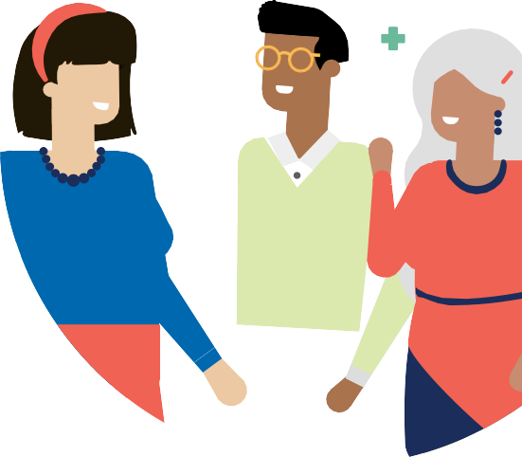

TEAM is a science-backed solution that allows organisations to foster an environment in which people can speak up, challenge the status quo, and experiment without fear of repercussions.



SET THE

STAGE

To establish clarity

INVITE

**PARTICIPATION**

To increase engagement

RESPOND

THOUGHTFULLY

To advance thinking



**What is psychological safety?**

A shared belief that people won’t be punished or humiliated for speaking up with ideas, questions, concerns, or mistakes. In such an environment, employee retention, agility, and performance thrive.

Psychological safety isn’t present by default — it requires deliberate action. NLI developed research-based habits to help drive behaviour change at scale.

TEAM gives every employee an easy-to-recall framework to feel safe to collaborate effectively, learn together, and find opportunities.

neuroleadership.com



© NeuroLeadership Institute



|  |  |  |  |  |  |  |  |  |  |  |
| --- | --- | --- | --- | --- | --- | --- | --- | --- | --- | --- |
|  |  |  |  |  |  |  |  |  |  |  |

###### Solution Overview



**Research Summaries** For a deeper dive into the brain science

Practice Tools

To support habit formation through practice

**Meeting Guides** For guided application to real workplace scenarios

Activities

For long-term sustainment and learning



**High Impact Virtual Experience (HIVE):**

Three 90-minute sessions using NLI’s HIVE methodology, impacting hundreds

to thousands of participants

**Distributed Learning Solution (DLS):**

Bite-sized video content delivered across four weeks to thousands of managers at a time

**In-Person Workshop:**

Expert-led, generative learning experiences, offered as a full-day session with tailoring options to fit your organisation’s needs

###### HIVE

The TEAM High Impact Virtual Experience provides learning in a virtual, facilitated delivery for cohorts of 12-30 in 90-minute sessions per week, in the flow of work, for 3 weeks.

 **Scale** Roll out to 100s or 1,000s of people at once

 **Speed** Small bites of digital info via a 30-day campaign

 **Impact** Brain-based learning that “sticks”

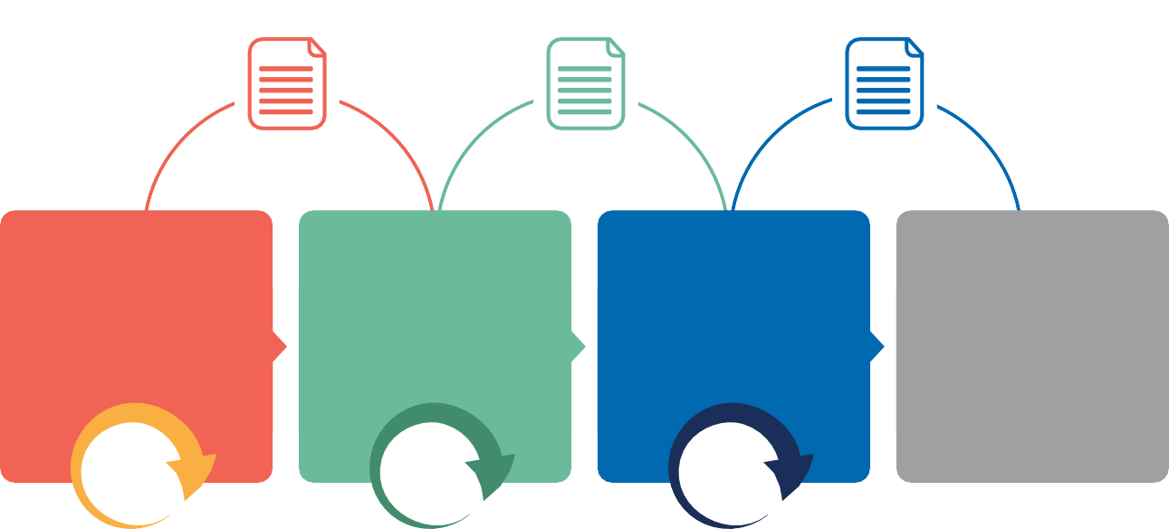Research summary and practice tool

Research summary and practice tool

Research summary, practice tool, and guides

#### Set the stage

HIVE Session 1

#### Invite participation

HIVE Session 2

#### Respond thoughtfully

HIVE Session 3

##### Program Evaluation & Measurement

90

min

90

min

90

min

Habits activated

at least once per week

#### For more information



**North America**



e: [northamerica@neuroleadership.com](mailto:northamerica@neuroleadership.com) | p: +01 (212) 260 2505

**Europe, Middle East, and Africa**



e: [emea@neuroleadership.com](mailto:emea@neuroleadership.com) | p: +44 (0) 845 456 3493

**Asia Pacific**



e: [apac@neuroleadership.com](mailto:apac@neuroleadership.com) | p: +61 2 9300 9878



|  |  |  |  |  |  |  |  |  |  |  |
| --- | --- | --- | --- | --- | --- | --- | --- | --- | --- | --- |
|  |  |  |  |  |  |  |  |  |  |  |

VOICE

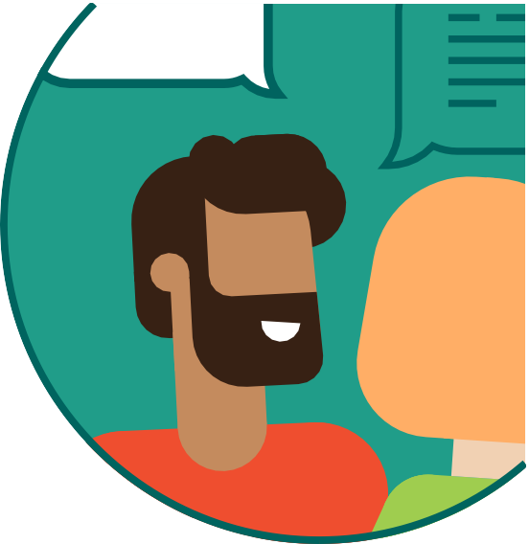

™

### Raise voices sooner, get results faster

Speaking up, even when constructive in intent, can be threatening.

**VOICE** has the power to help people share ideas, question decisions, and challenge behaviours more frequently and productively. This will encourage engagement, inclusion, productivity, and innovation. Unless organisations actively equip their people to find their **VOICE**, silence prevails.



**NOTICE**

THE MOMENT

Recognise the moment for when speaking up is the right thing to do

**MANAGE**

YOUR EMOTION

Use proven, scientific methods to manage your emotions when approaching a speaking-up conversation

**CHALLENGE**

PRODUCTIVELY

Acknowledge and encourage others to speak up in a productive manner

Speaking up is essential to share ideas, question decisions, and challenge behaviours. But how do you help people move from a place of silence to finding their voice?

Employees don’t keep quiet or speak up just because it’s their personality. Often, the work environment plays an outsized role in whether people find their voice. Specifically, it may all come down to social threat, or the performance-limiting experience of feeling powerless, excluded, or uncertain in social contexts. The science of social threat and reward can amplify quiet voices and unlock hidden potential.

###### The SCARF® Model

SCARF® concerns the way we send social threats and rewards in five key domains: status, certainty, autonomy, relatedness, and fairness. Individuals can use the SCARF® Model to understand the potential social threat in a speaking-up moment and use SCARF® signals to speak up in a less threatening, more productive manner.

**AWAY** THREAT

Threat Is Stronger

**S**TATUS **C**ERTAINTY **A**UTONOMY **R**ELATEDNESS **F**AIRNESS

**TOWARD** REWARD

Reward Is Better

neuroleadership.com



© NeuroLeadership Institute



|  |  |  |  |  |  |  |  |  |  |  |
| --- | --- | --- | --- | --- | --- | --- | --- | --- | --- | --- |
|  |  |  |  |  |  |  |  |  |  |  |

###### Solution Overview



**Research Summaries** for a deeper dive into the brain science

Practice Tools

to support habit formation through practice

**Decision Guides** for guided application to real workplace decisions

Activities

for long-term sustainment and learning

**Distributed Learning Solution (DLS):**

Bite-sized video content delivered across four weeks to thousands of managers at a time

**High Impact Virtual Experience (HIVE):**

Three 90-minute sessions using NLI’s HIVE (High Impact Virtual Experience) methodology, impacting hundreds to thousands of participants

**Executive Briefings and Private Webinars:**

Expert-led, generative learning experiences with tailoring options to fit your organisation’s needs

###### Days to Integrate

**30**

The **VOICE** Distributed Learning Solution seamlessly integrates into your organisation and turns these essential skills into sustainable habits.

Get **5-Minute Research Videos** for an overview of the core content and a Live Webinar or a **Discussion Toolkit** for a holistic, interactive debrief.



**Scale** Roll out to 100s or 1,000s of people at once **Speed** Small bites of digital info via a 30-day campaign **Impact** Brain-based learning that “sticks”

FOLLOW-UP

Sustainment

CHALLENGE

INTERACTIVE DISCUSSION

LAUNCH

NOTICE

5-minute video Research Summary Practice Tool

MANAGE

5-minute video Research Summary Practice Tool

5-minute video Research Summary Practice Tool



#### For more information

**North America**



e: [northamerica@neuroleadership.com](mailto:northamerica@neuroleadership.com) | p: +01 (212) 260 2505

**Europe, Middle East, and Africa**



e: [emea@neuroleadership.com](mailto:emea@neuroleadership.com) | p: +44 (0) 845 456 3493

**Asia Pacific**



e: [apac@neuroleadership.com](mailto:apac@neuroleadership.com) | p: +61 2 9300 9878